Project: User Engagement & Retention Analysis

"Analysed login patterns, inactive users, and high-value customers to drive retention strategies"

**Overview**

The User Login Activity Analysis System is a database-driven project designed to manage and analyse user login activities for a business application. The system tracks user information and their login sessions, enabling the business to derive insights into user engagement, session trends, and activity patterns. The project involves two primary tables: users and logins, with SQL queries developed to address specific business requirements such as identifying inactive users, analysing quarterly session trends, and recognizing top-performing users based on session scores and consistency.

**Database Schema:**

CREATE TABLE users (

USER_ID INT PRIMARY KEY,

USER_NAME VARCHAR(20) NOT NULL,

USER_STATUS VARCHAR(20) NOT NULL

);

CREATE TABLE logins (

USER_ID INT,

LOGIN_TIMESTAMP DATETIME NOT NULL,

SESSION_ID INT PRIMARY KEY,

SESSION_SCORE INT,

FOREIGN KEY (USER_ID) REFERENCES USERS(USER_ID)

);

**Key Business Questions & Analysis**

* Inactive Users (No Logins in Past 5 Months)
  + Retrieve users who have not logged in since January 28, 2024.
* Quarterly User & Session Analysis
  + Calculate the number of unique users and total sessions per quarter, ordered from newest to oldest.
  + Return: Quarter start date, user count, session count.
* Users Active in January 2024 but Not in November 2023
  + Identify users who logged in January 2024 but had no logins in November 2023.
* Quarterly Session Growth Rate
  + Extend the query from Question 2 to include:
    - Session count
    - Previous quarter’s session count
    - Percentage change in sessions
  + Return: Quarter start date, session count, previous session count, % change.
* Daily Top Performers (Highest Session Score per Day)
  + For each day, find the user with the highest session score.
  + Return: Date, username, max score.
* Most Consistent Users (Logged in Every Day Since First Login)
  + Identify users who logged in every single day since their first login (assume no breaks).
  + Return: User ID.
* Dates with Zero Logins
  + Find dates where no logins occurred at all.
  + Return: Login date (with zero activity).

**Expected Outcomes**

* Identification of inactive users for re-engagement campaigns.
* Insights into quarterly user & session trends for business planning.
* Recognition of top-performing users based on session scores.
* Detection of platform downtime (dates with no logins).
* Understanding user retention patterns (consistent vs. sporadic logins).

**Technologies & Methods Used**

* SQL (Window functions, subqueries, aggregations, date filtering)
* Time-Series Analysis (Quarterly trends, daily activity)
* Data-Driven Decision Making (User engagement strategies, retention analysis)

1. Managment wants to see all the users that did not login in past 5 months

select max(LOGIN_TIMESTAMP) from logins --2024-06-28 --2024-01-28

--WAY 1

select USER_ID, MAX(LOGIN_TIMESTAMP) as MAX_DATE

from logins

group by USER_ID

having max(LOGIN_TIMESTAMP)<'2024-01-28'

--WAY 2

select distinct USER_ID

from logins

where USER_ID not in(select USER_ID

from logins

where LOGIN_TIMESTAMP>'2024-01-28')

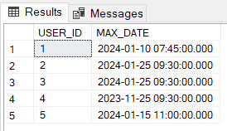

2.For the business units quaterly analysis, calculate how many users and how many sessions were at each quarter,

order by quater from newest to oldest.

return first day of the quarter, user count, session count

assumption: considered quater only irrespective of year

select * from logins

select DATEPART(QUARTER,LOGIN_TIMESTAMP) as QUATER_NO

,min(LOGIN_TIMESTAMP) as QTR_FIRST_LOGIN

,count(distinct USER_ID) as USER_COUNT

,sum(SESSION_SCORE) as SESSION_COUNT

--,DATETRUNC(QUARTER,min(LOGIN_TIMESTAMP)) as FIRST_QUATER_DATE

from logins

group by DATEPART(QUARTER,LOGIN_TIMESTAMP

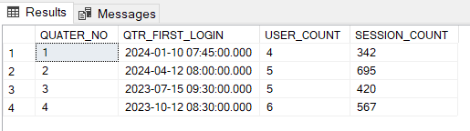

3. Display user id that log-in in January 2024 and did not login in on November 2023

--january 2024 1 2 3 5

--novemeber 2023 2 4 6 7

select USER_ID

from logins

where MONTH(LOGIN_TIMESTAMP)=1 and YEAR(LOGIN_TIMESTAMP)=2024

and user_id not in (select USER_ID

from logins

where MONTH(LOGIN_TIMESTAMP)=11 and YEAR(LOGIN_TIMESTAMP)=2023

group by USER_ID)

group by USER_ID

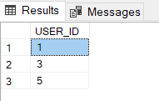

4. Add to the query from question 2 the percentage change in the session form the last quater

return- first day of the quater, session cnt,

session cnt previous, session percentage change.

select *,(SESSION_COUNT-CHANGE_LST_QTR)*100/CHANGE_LST_QTR as PERCENTAGE_CHANGE from(

select *

,LAG(SESSION_COUNT,1,SESSION_COUNT) over(order by QUATER_NO) as CHANGE_LST_QTR

from(

select DATEPART(QUARTER,LOGIN_TIMESTAMP) as QUATER_NO

,min(LOGIN_TIMESTAMP) as QTR_FIRST_LOGIN

,count(distinct USER_ID) as USER_COUNT

,COUNT(*) as SESSION_COUNT

--,DATETRUNC(QUARTER,min(LOGIN_TIMESTAMP)) as FIRST_QUATER_DATE

from logins

group by DATEPART(QUARTER,LOGIN_TIMESTAMP)) A) B

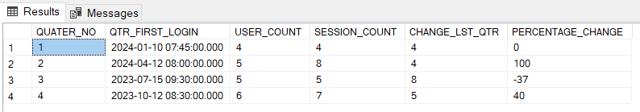

5. Display the user that had highest session score(max) for each day

return: date, username, score

select LOGIN_DATE

,MAX(SUM_SCORE) as MAXIMUM_SESSION_SCORE

from(

select USER_ID

,cast(LOGIN_TIMESTAMP as date) as LOGIN_DATE

,SUM(SESSION_SCORE) as SUM_SCORE

from logins

group by USER_ID,cast(LOGIN_TIMESTAMP as date)) A

group by LOGIN_DATE

order by LOGIN_DATE

select *

from(

select *

,ROW_NUMBER() over(partition by DATEE order by SUMSCORE desc) as rn

from(

select USER_ID

,cast(LOGIN_TIMESTAMP as date) as DATEE

,sum(SESSION_SCORE) as SUMSCORE

from logins

group by USER_ID, cast(LOGIN_TIMESTAMP as date)) A) B

where rn=1

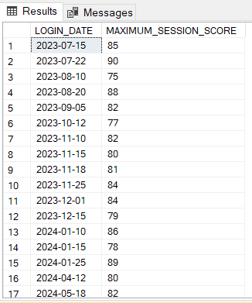

6. To identify our best users - return the user that had a session on every single day since their first login

(make assumption if needed)

return- userid

select *

from(

select *

,DATEDIFF(DAY,MIN_LOGIN_DATE,MAXIMUM_LOGIN_DATE)+1 as DAYS_BETWEEN

from(

select USER_ID

,MIN(LOGIN_TIMESTAMP) as MIN_LOGIN_DATE

,MAX(LOGIN_TIMESTAMP) as MAXIMUM_LOGIN_DATE

,COUNT(*) as TOTAL_NO_OF_LOGINS

from logins

group by USER_ID) A)B

where DAYS_BETWEEN=TOTAL_NO_OF_LOGINS

select USER_ID

,MIN(cast(LOGIN_TIMESTAMP as date)) as FIRST_LOGIN

,max(cast(LOGIN_TIMESTAMP as date)) as LAST_LOGIN

,DATEDIFF(DAY,MIN(cast(LOGIN_TIMESTAMP as date))

,max(cast(LOGIN_TIMESTAMP as date)))+1 as DATE_DIFF

,COUNT(USER_ID) as TOTAL_LOGIN

from logins

group by USER_ID

having COUNT(USER_ID)=DATEDIFF(DAY,MIN(cast(LOGIN_TIMESTAMP as date)),max(cast(LOGIN_TIMESTAMP as date)))+1

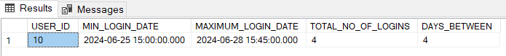

7. On what date there were no login at all

--return- login date

select min(LOGIN_TIMESTAMP)as MIN_DATE,max(LOGIN_TIMESTAMP)as MAX_DATE

from logins

--2023-07-15

--2024-06-28

recursive cte for creating date table from the min date to max date

with cte as (

select cast('2023-07-15' as date) as CAL_DATE

union all

select DATEADD(day,1,CAL_DATE) as CAL_DATE

from cte

where CAL_DATE<cast('2024-06-28' as date)

)

select * into CAL_TABLE

from cte

option(maxrecursion 500)

select *

from CAL_TABLE c

left join

(select cast(LOGIN_TIMESTAMP as date)as REQ_DATE

from logins) a

on c.CAL_DATE=a.REQ_DATE

where REQ_DATE is null

